Student ID: 11657718

Student Name: Kushal Regmi

Subject Code: 161

Subject Name: ITC

Assignment Number: 1

Lecturer Name: Rajasekaran LAKSHMIGANTHAN

1. Describe Moore’s Law. Discuss its implications and limitation with respect to the current trend in computing.

Ans : Moore’s Law states “The density of transistors in an integrated circuit will double every year.” (Null & Lobur, 2014)

1. Convert the followings:  
   a. 1235  into octal representation

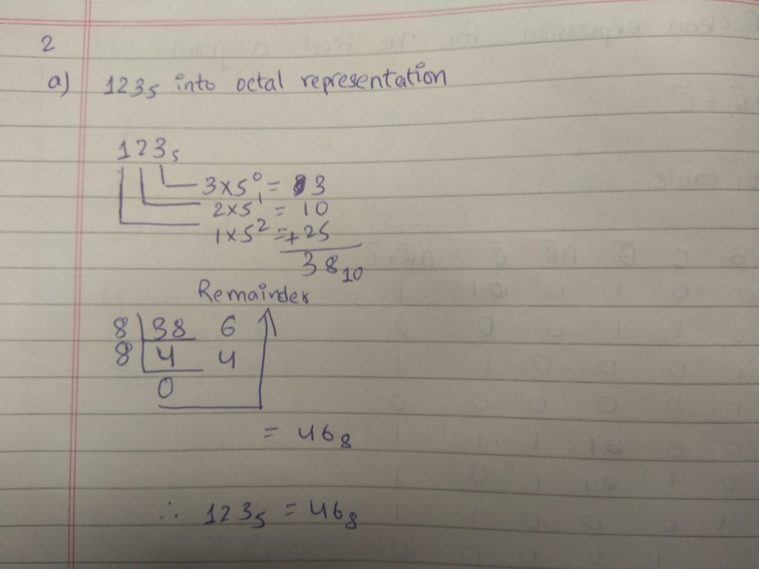

\

b. 0xADD into 3-base representation

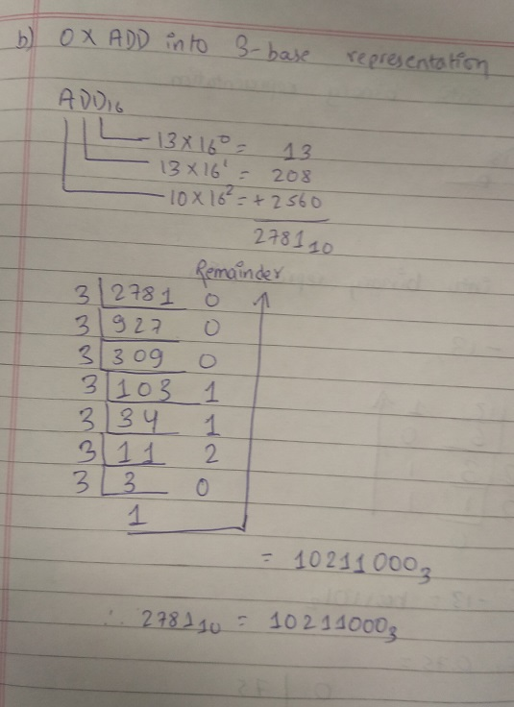

c. -13.7510into binary representation

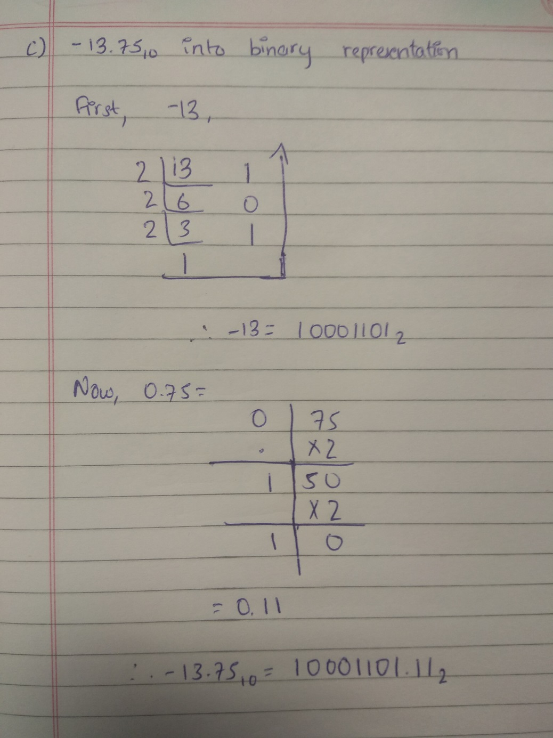

1. A computer stores the floating point value using IEEE754 single precision format. What value (in decimal) the computer stores if it stores the following? Please show all steps.

**11000010110100000000000000000000**

**Sign bit s = 1 (The number should be negative)**

**Exponent e = 10000101 = 1*20** +1*22 +1*27 =1+4+128 = 133

Mantissa m = 10100000000000000000000

Bias k =127 (as 8 bits are used in IEE754)

The floating point is = (-1)s x 1.m x 2e-k

= (-1)1 x 1.101 x 2133-127

= -1.625 x 26

= -104

1. Considering A and B are Boolean variables, simplify the following Boolean expression using Boolean Identities. Please list all rule(s) used for the simplification process.

**A'(A + B) + (B + AA)(A + B')**

* 